**Task 11: Create a simple project with Jenkins connected to your GitHub repository. When a commit is made to your repo, automatically build must get triggered from Jenkins and the output must be shared via email."**

1. **Create a simple project with Jenkins connected to your GitHub repository:**

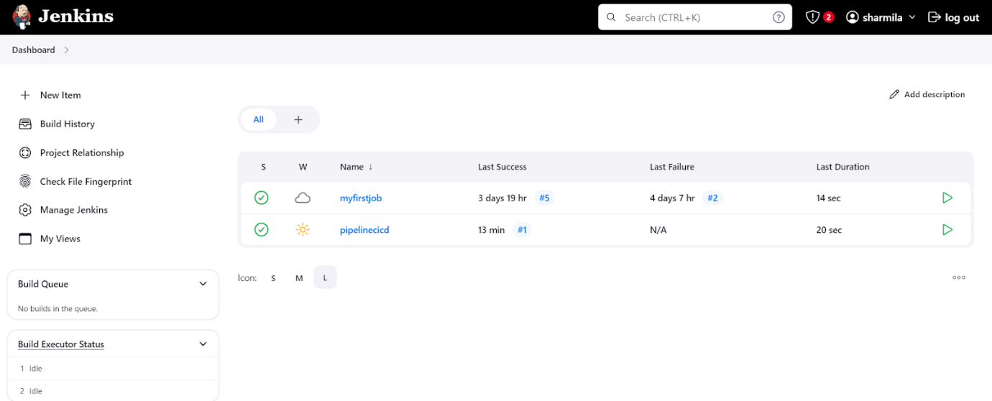

**Pipelinecicd project:**

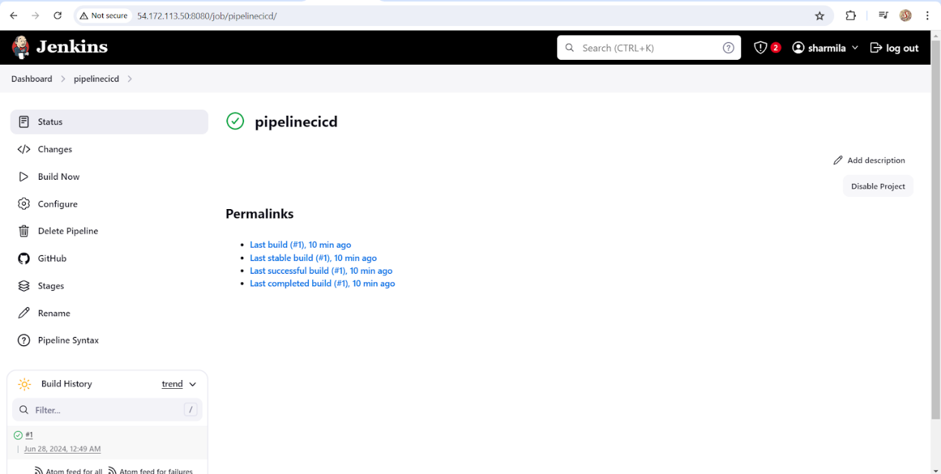

**Github repository:**

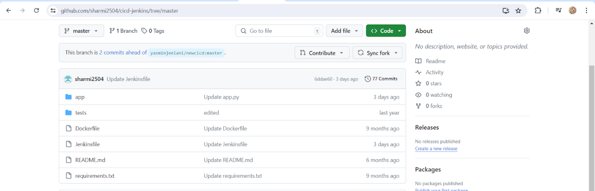

**Console output:**

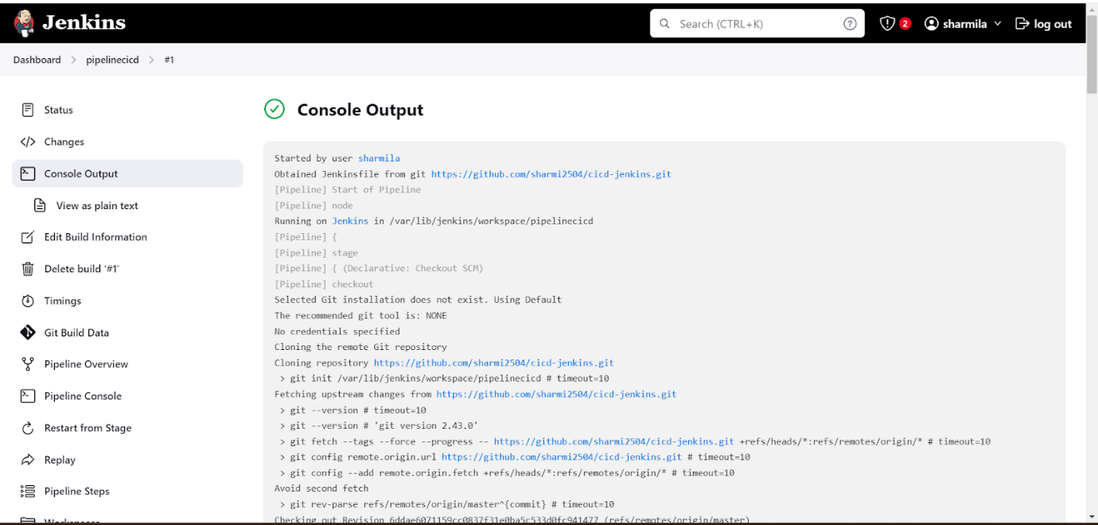

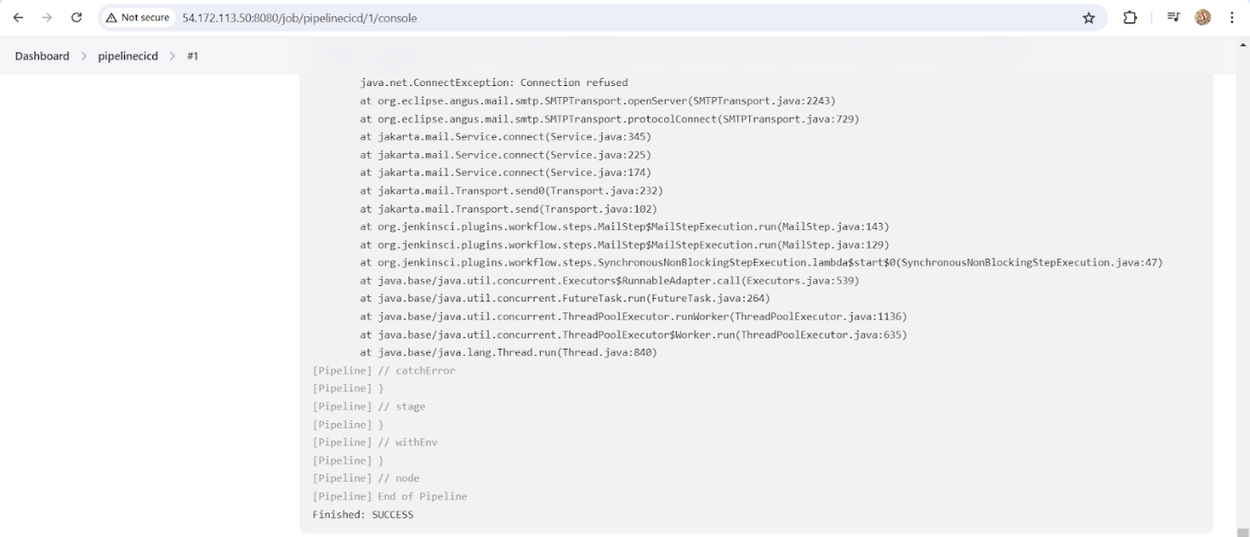

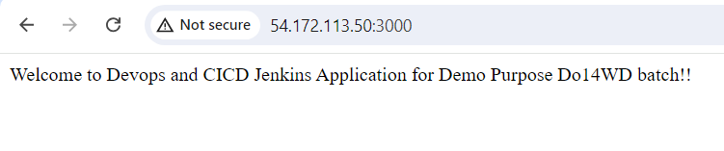

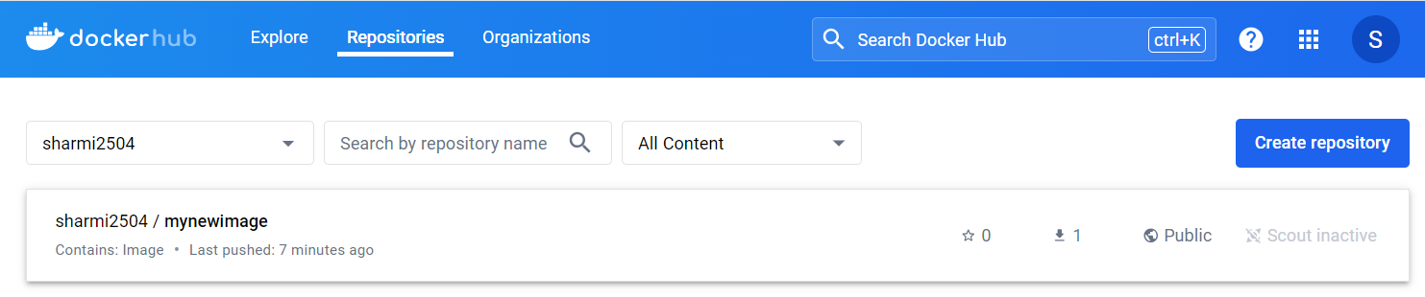

1. **Configure the mail in jenkins:**

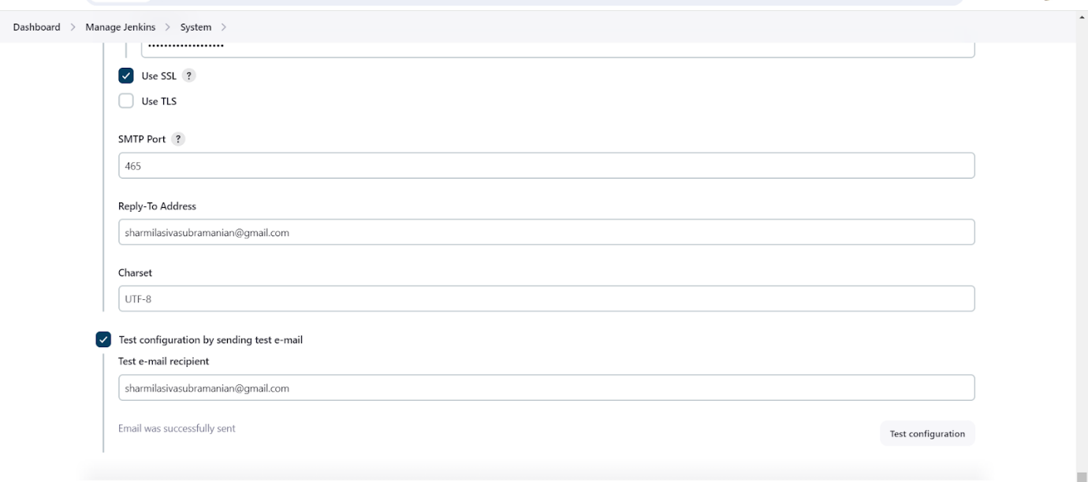

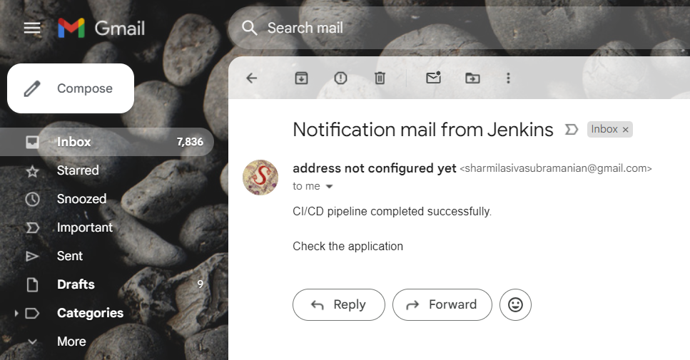

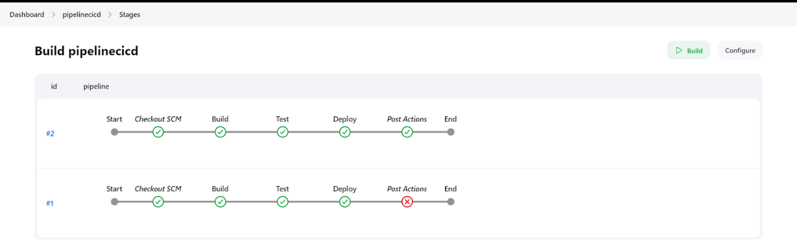

1. **When a commit is made to your repo, automatically build must get triggered from Jenkins:**

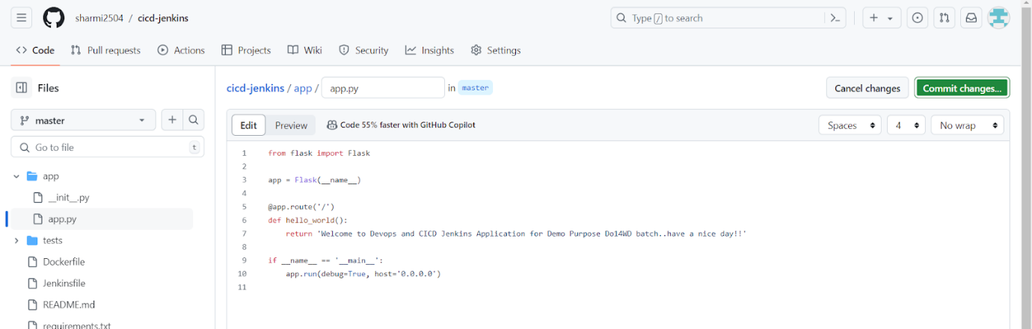

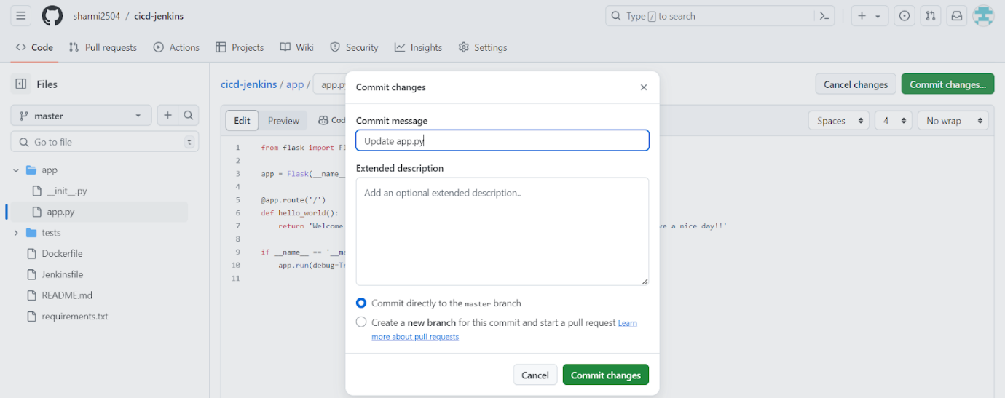

1. **The output must be shared via email:**

